**Disaster Animation Exercise**

**Student Name: Pulkit Agrawal Student Id: PXA180017**

**Date: 11-02-2018**

**Question:**

1. **Provide the screenshot of your workbook:**

**Answer**

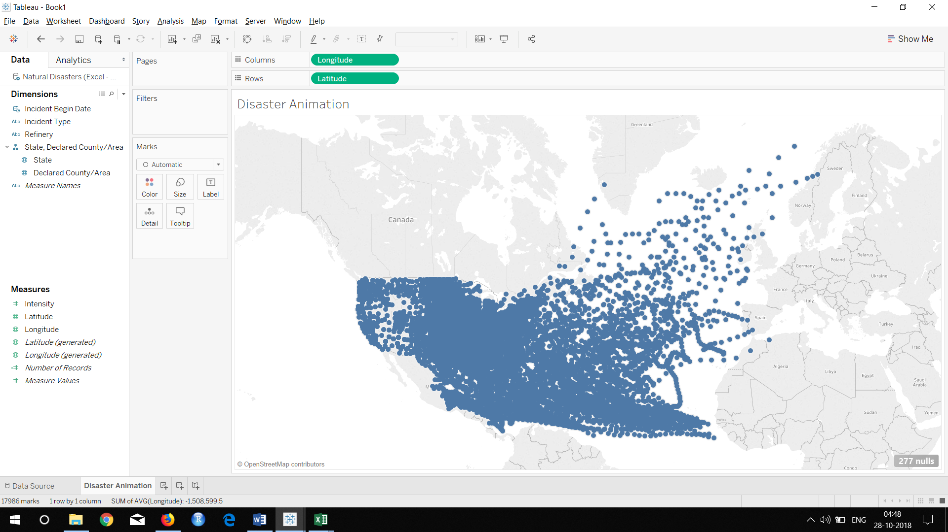

**Question:**

1. **Provide the screenshot of your Tableau sheet:**

**Answer**

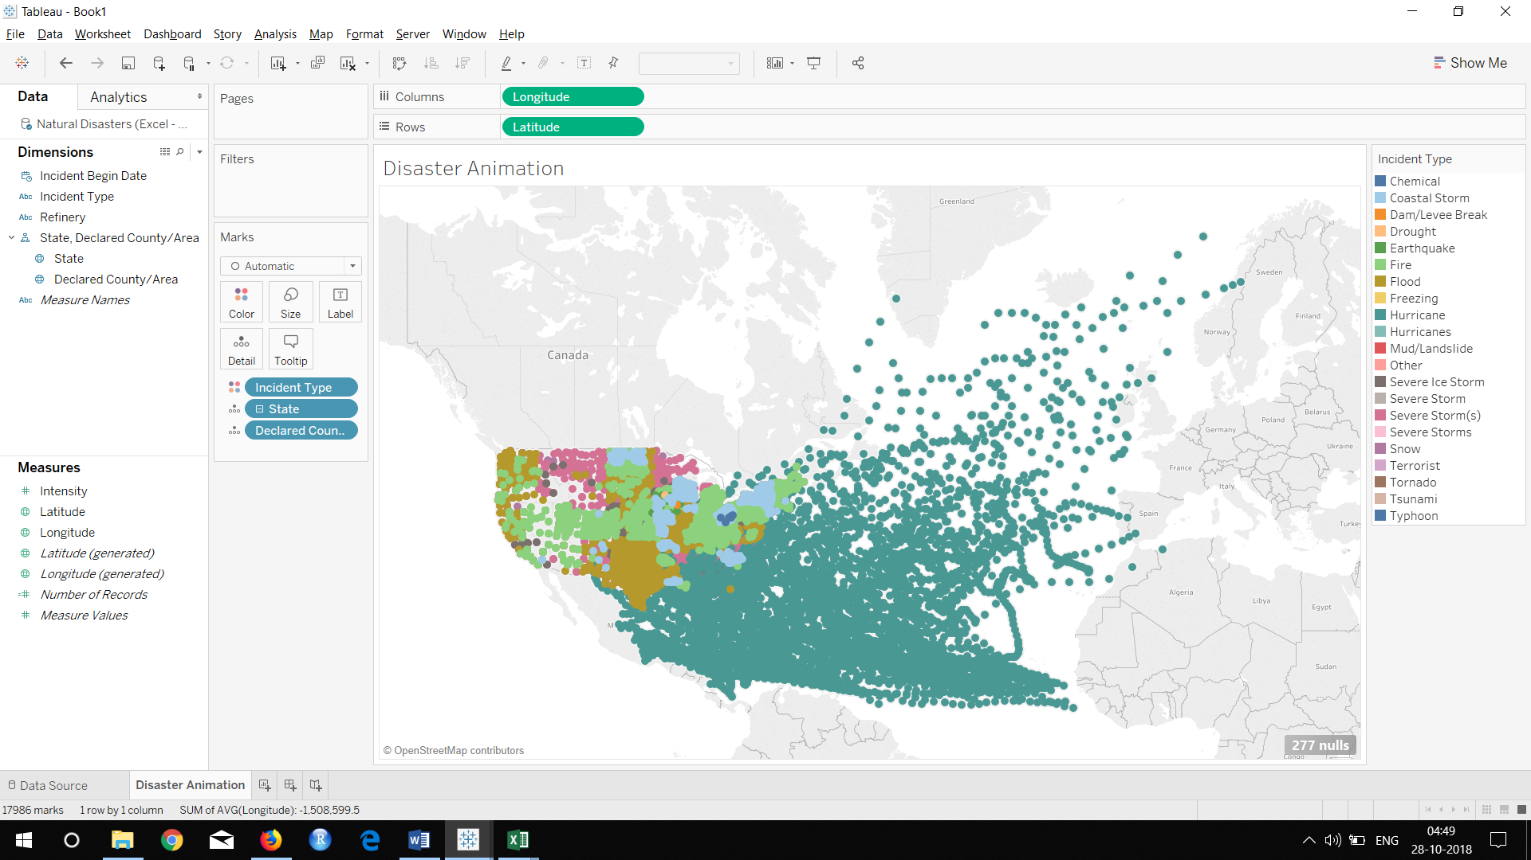

**Question:**

1. **Why did all the data disappear from the map?**

**Answer As we selected only null values to be displayed in the longitude filter we are not able to see any values in the output map.**

**Questions:**

1. There are some counties which have ‘PMSA’ string concatenated to their name, what does PMSA mean? **Hint**: use internet/Wiki to find the answer

**Answer Primary Metropolitan Statistical Areas (PMSA) are subareas that meet the qualification to be an MSA, but have a population of one million or more**

1. There are some counties which have ‘MSA’ string concatenated to their name, what does MSA mean? **Hint**: use internet/Wiki to find the answer

**Answer a metropolitan statistical area (MSA) is a geographical region with a relatively high population density at its core and close economic ties throughout the area. Such regions are neither legally incorporated as a city or town would be, nor are they legal administrative divisions like counties or separate entities such as states**

1. There are quite a few counties which have a common string concatenated to their name (apart from PMSA and MSA), what is that string and what does it mean?

**Answer Reservation- An Indian reservation is a legal designation for an area of land managed by a federally recognized Native American tribe under the U.S. Bureau of Indian Affairs rather than the state governments of the United States in which they are physically located.**

**Question:**

1. **Paste the screen shot of those counties for which you have found latitude longitude manually. Your screen shot should show County, State, latitude, longitude.**

**Answer none**

**Question:**

1. Paste the screen shot of your Tableau sheet

**Answer**

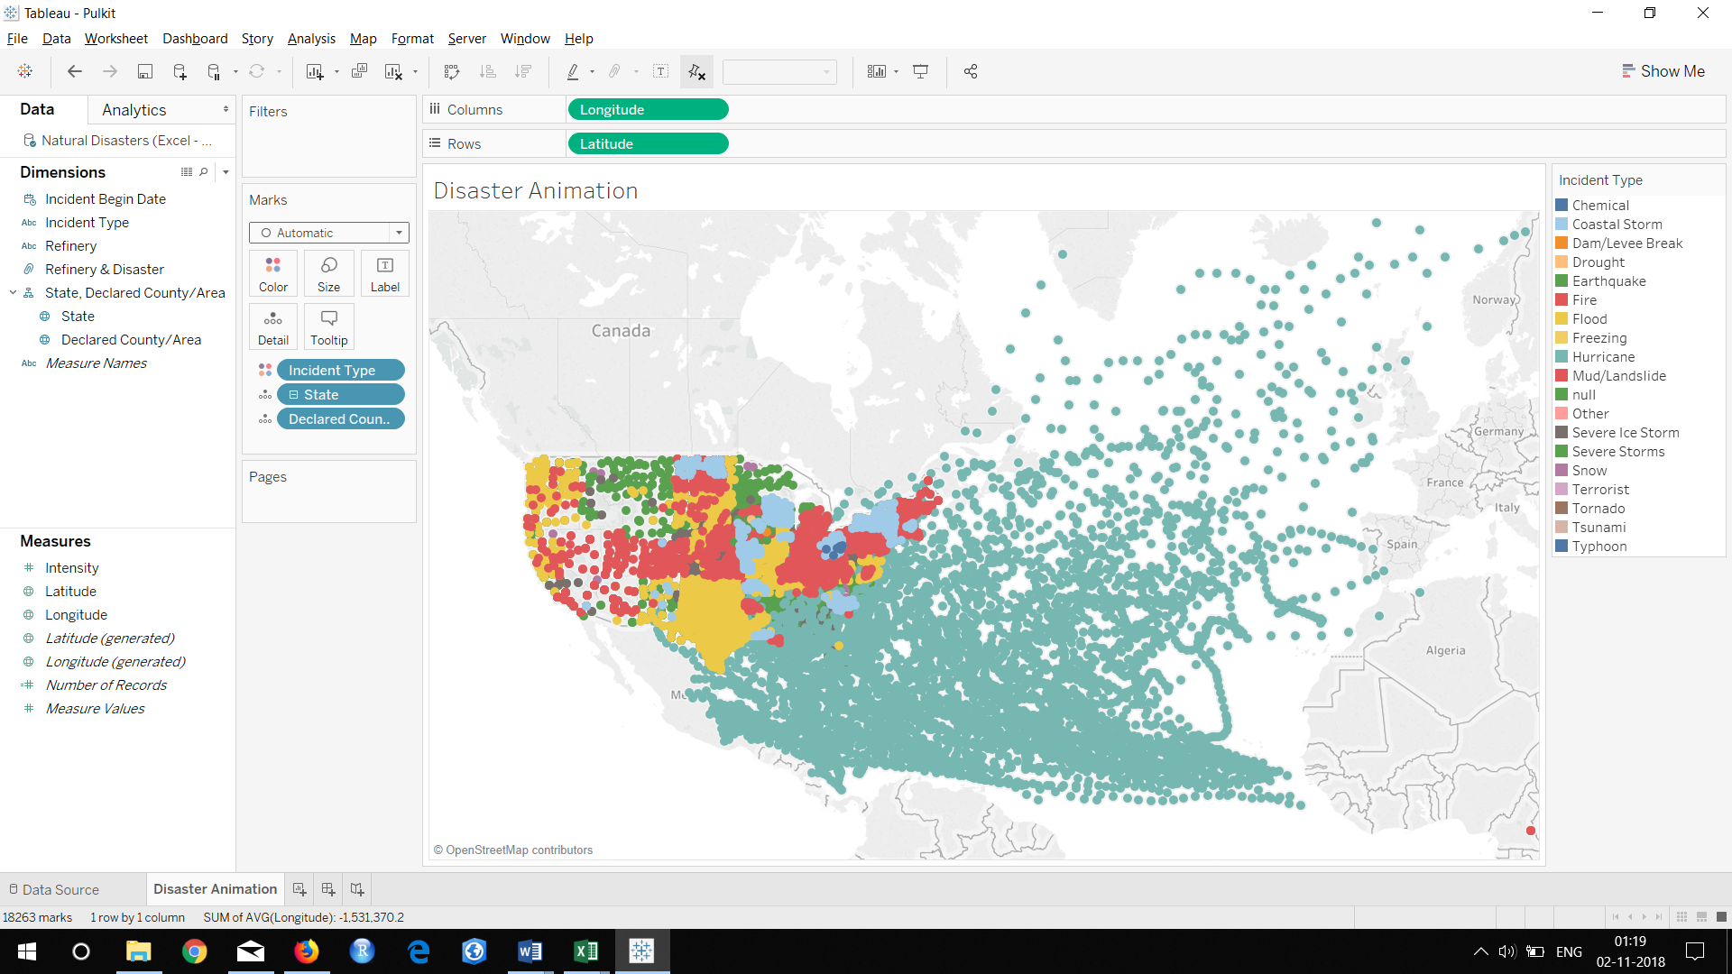

**Question:**

1. **Paste the screen shot of your Tableau sheet**

**Answer**

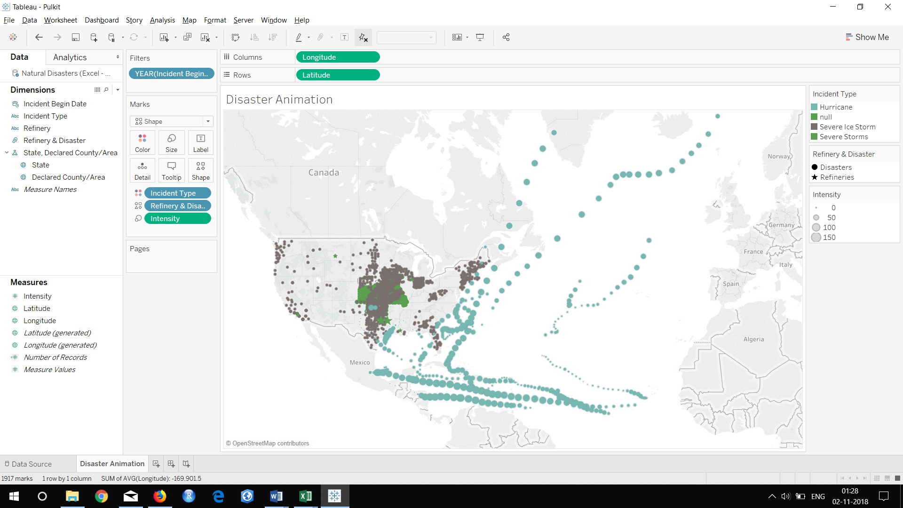

**Question:**

1. Add Incident Type and Incident Begin Year to label card (display Year and Month as label) and paste the screen shot of your ‘Marks’ pane.

**Answer**

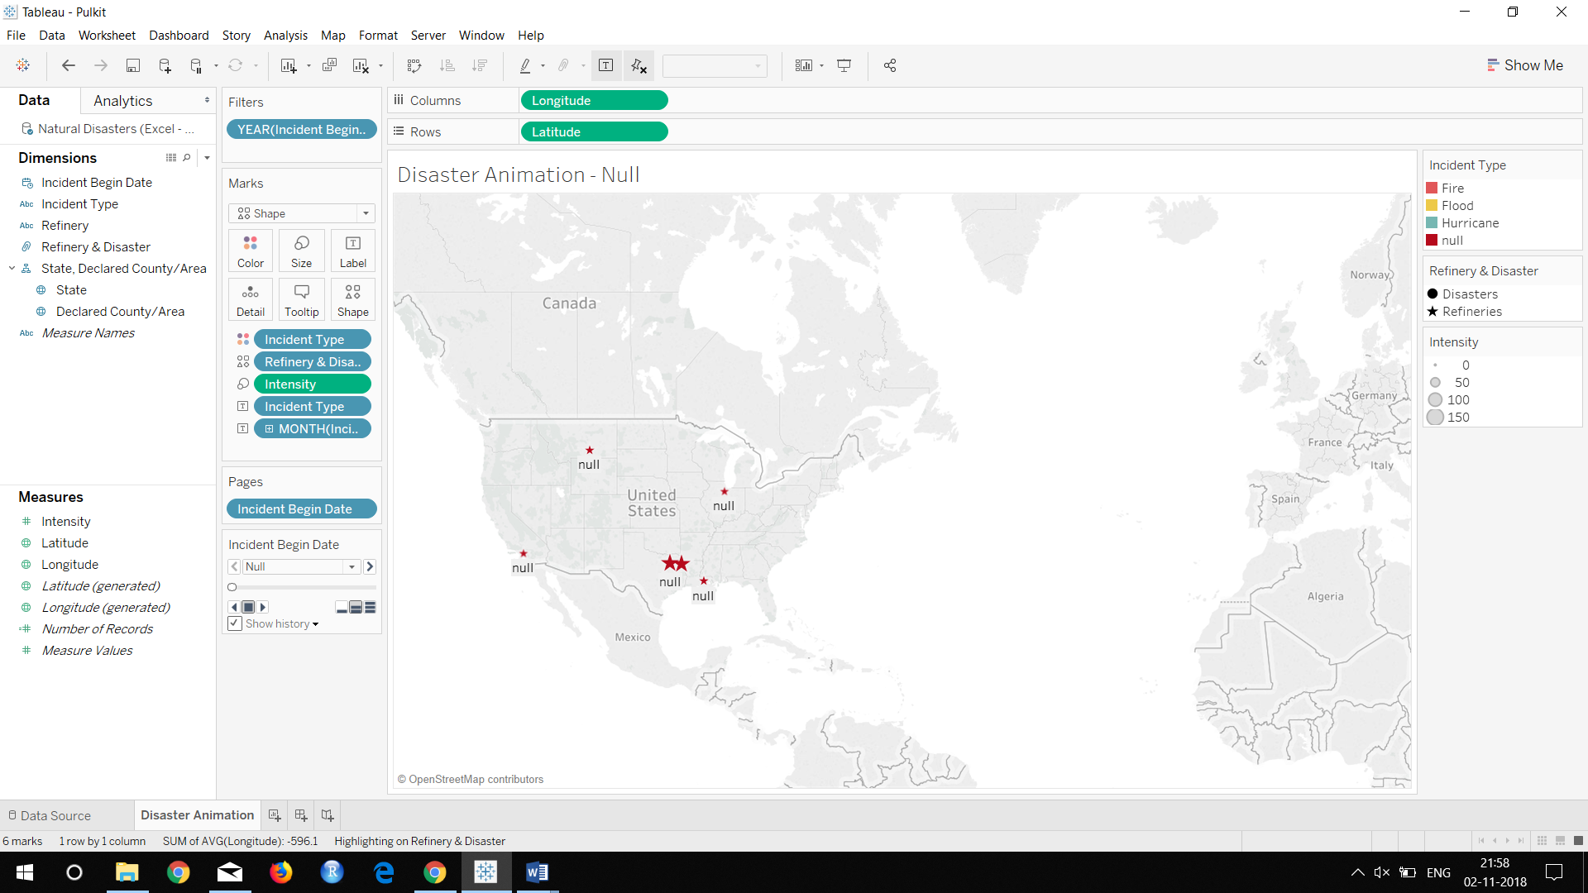

1. Make changes in your Tool Tip, only ‘Incident Begin Date’ and ‘Incident Type’ should appear as tool tip. Click on tool tip card and paste the screen shot of pop-up.

**Answer**

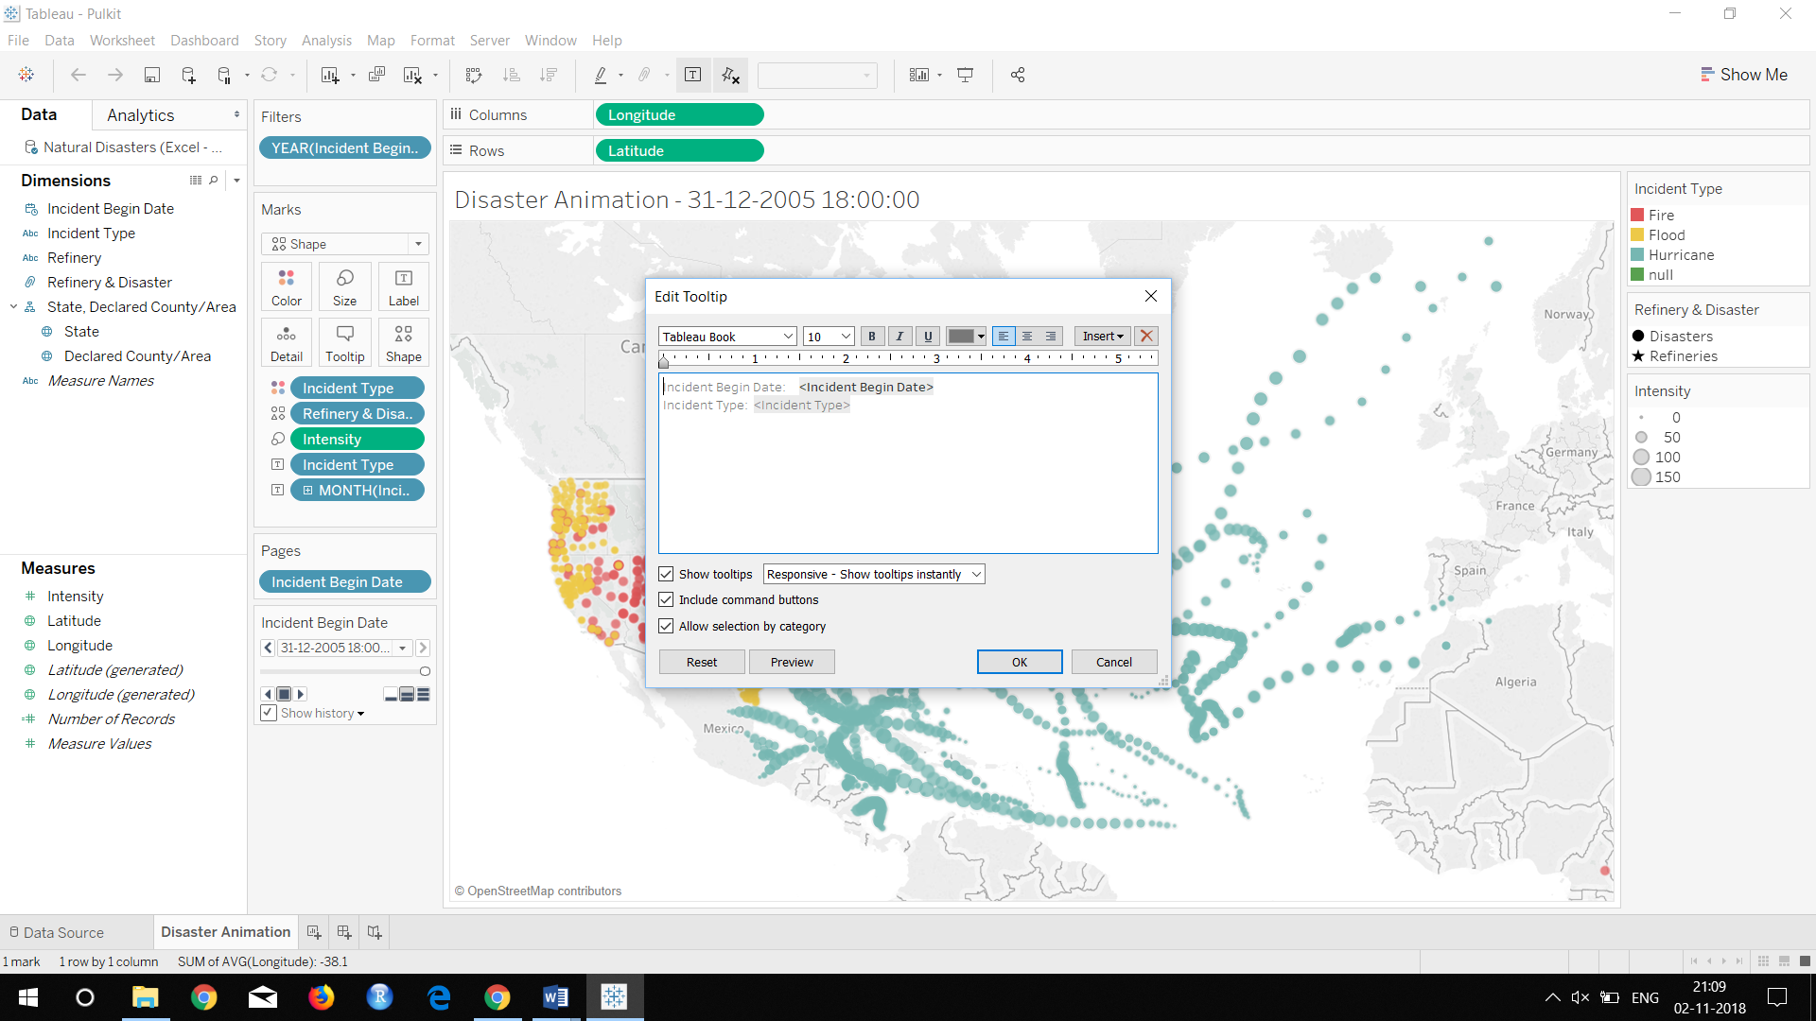

**Question:**

1. Run disaster simulation for year 2005 and list the refinery locations impacted by disasters

**Answer** ExxonMobil Baytown Refinery USA, ExxonMobil Beaumont Refinery, ExxonMobil Torrance Refinery, ExxonMobil Joliet Refinery, ExxonMobil Billings Refinery are the refineries which were affect by the disasters.

ExxonMobil Baton Rouge Refinery was not affected by the the disaster.